Experiment NO.3

**Title:** Exploring and Managing Raster Data: Adding Raster layers, Raster styling and Analysis , Raster mosaicking and clipping

**a)Adding Raster Layer**

**Step 1:**

Go to layer→ Add Layer → Add Raster Layer

To start with analysis of population data,convert the pixel from gray scale to color.

Select “glds90ag60.asc” layer from layer pane select property OR double click on it.

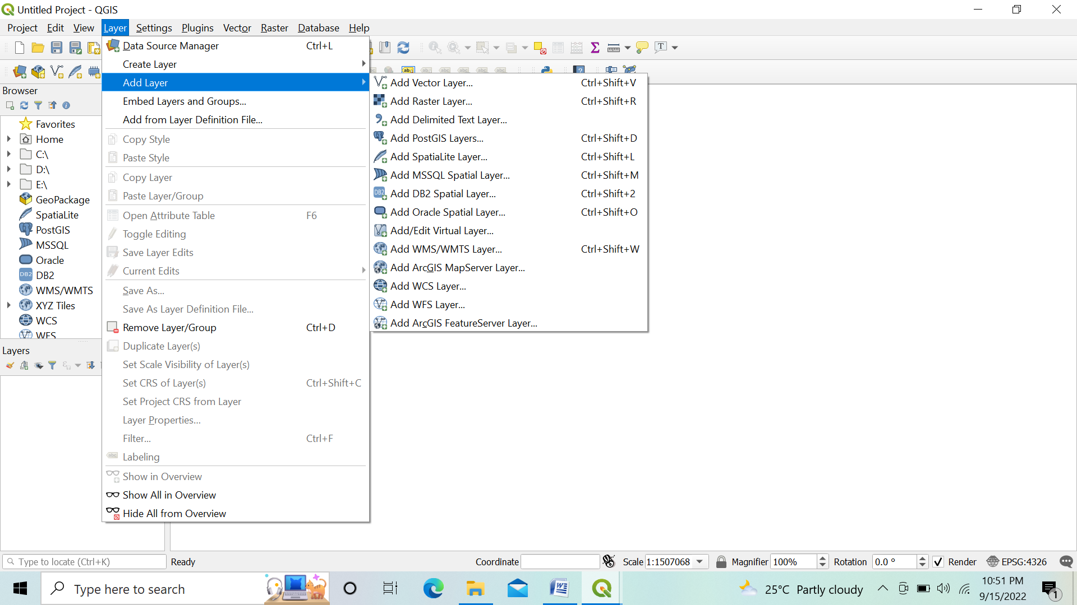

**Step 2:**

* Add Symbology to both data in between rang 0 to 240

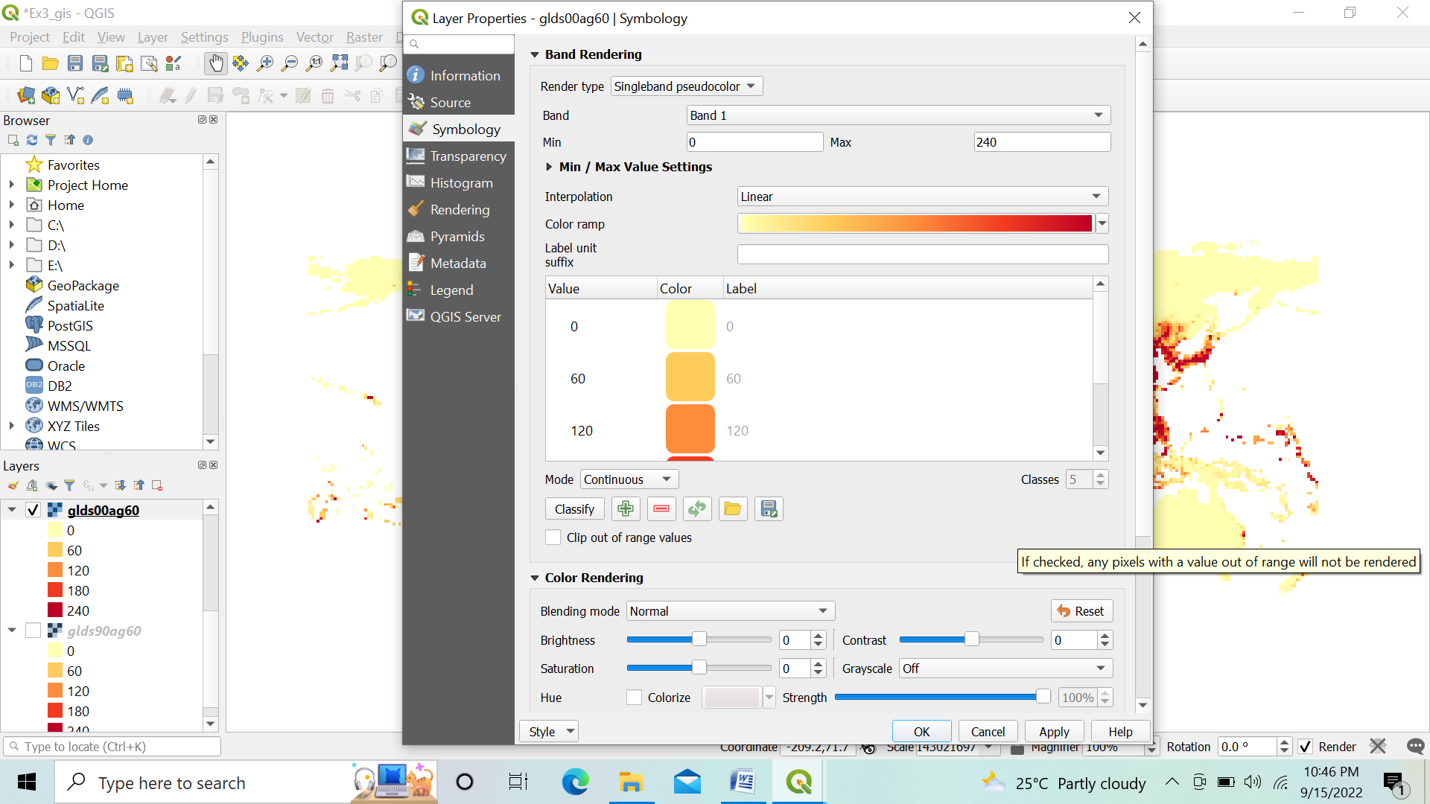

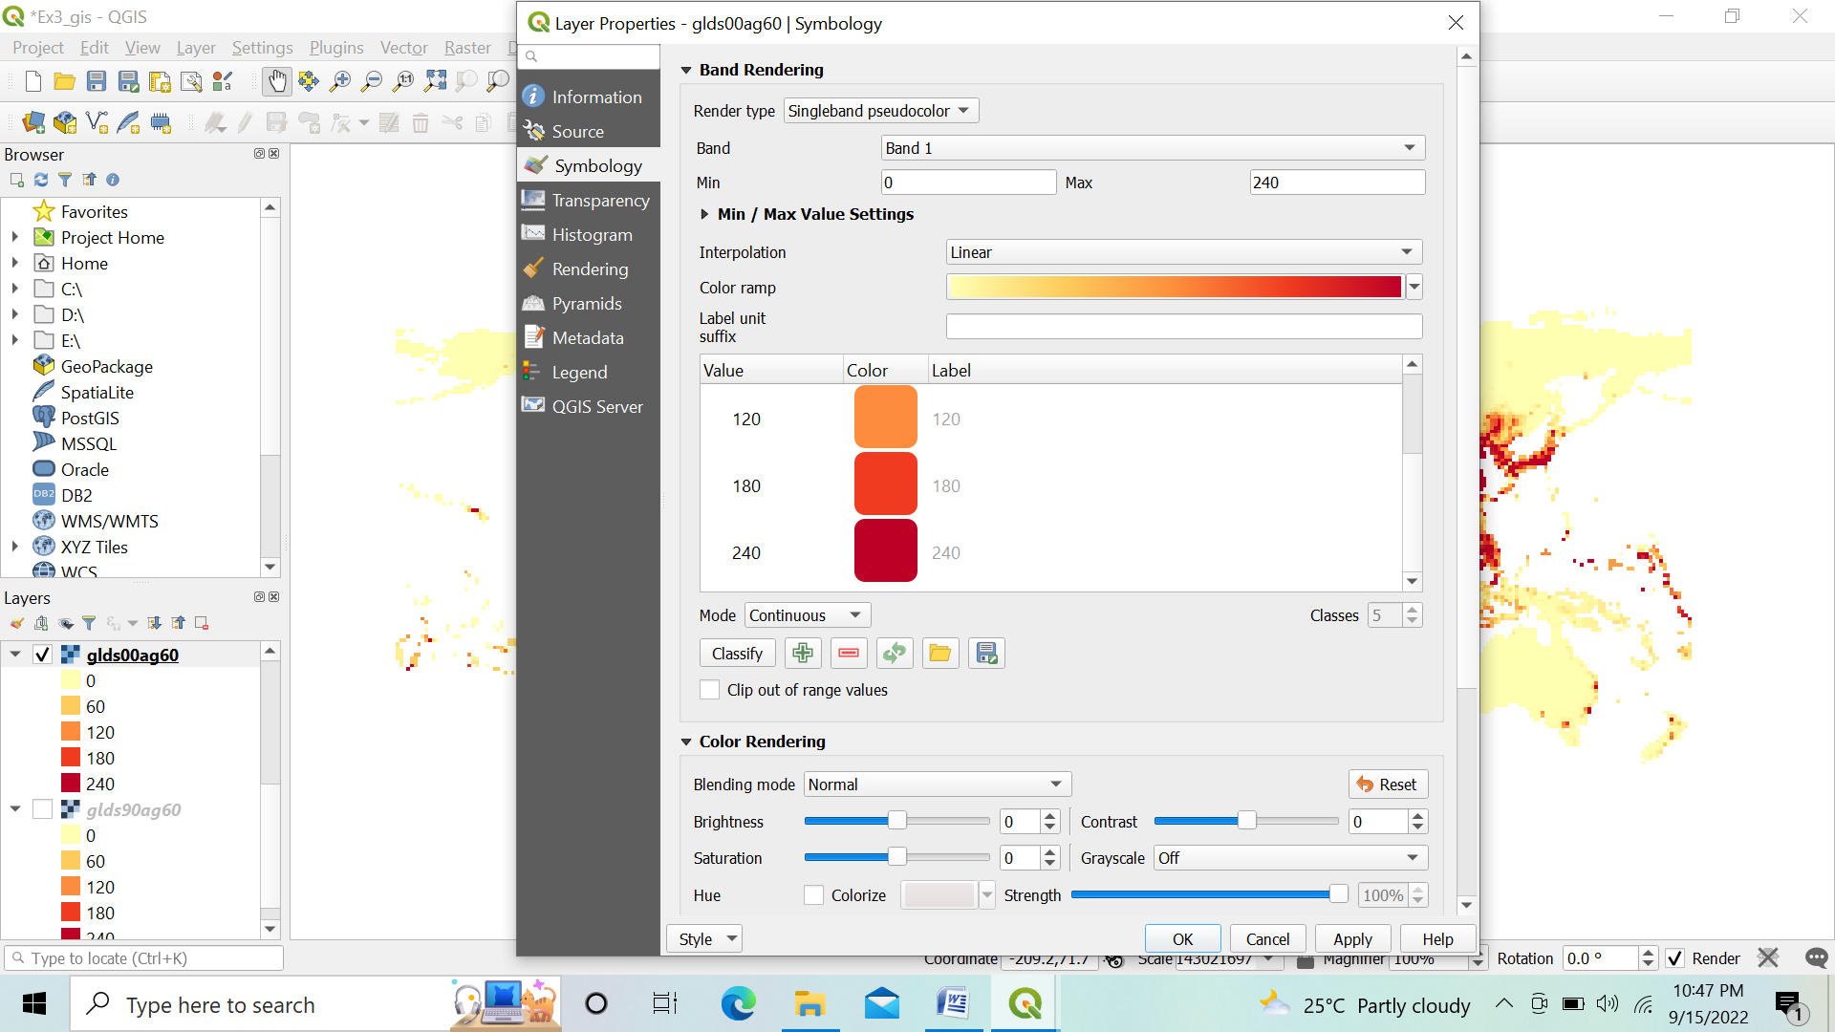

Press “Apply” Repeat the same for “glds00ag60.asc” layer After applying style:

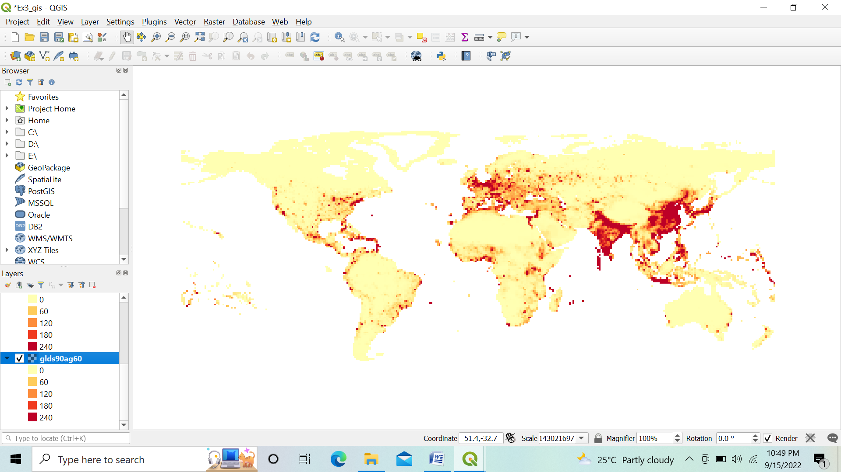

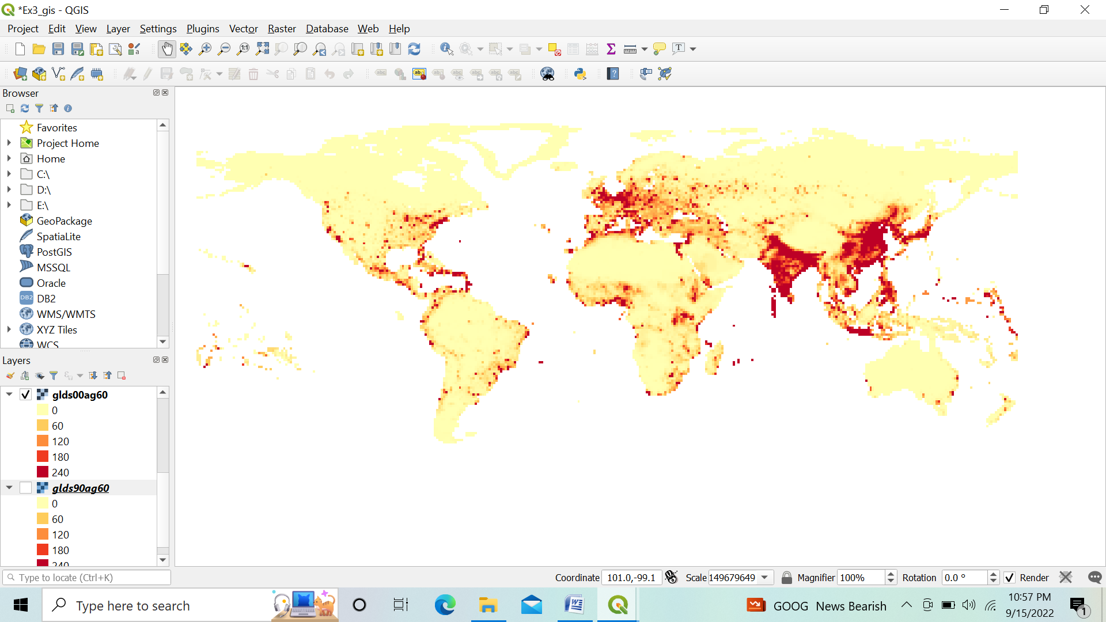

We have to analyze raster data, as an example we will find areas with largest population change between

1990 And 2000, by calculating the difference between each pixel values.

**Raster calculation:**

Go to Raster → Raster Calculator

Put the expression "glds00ag60@1" - "glds90ag60@1"

Select the output file location & name and Press OK

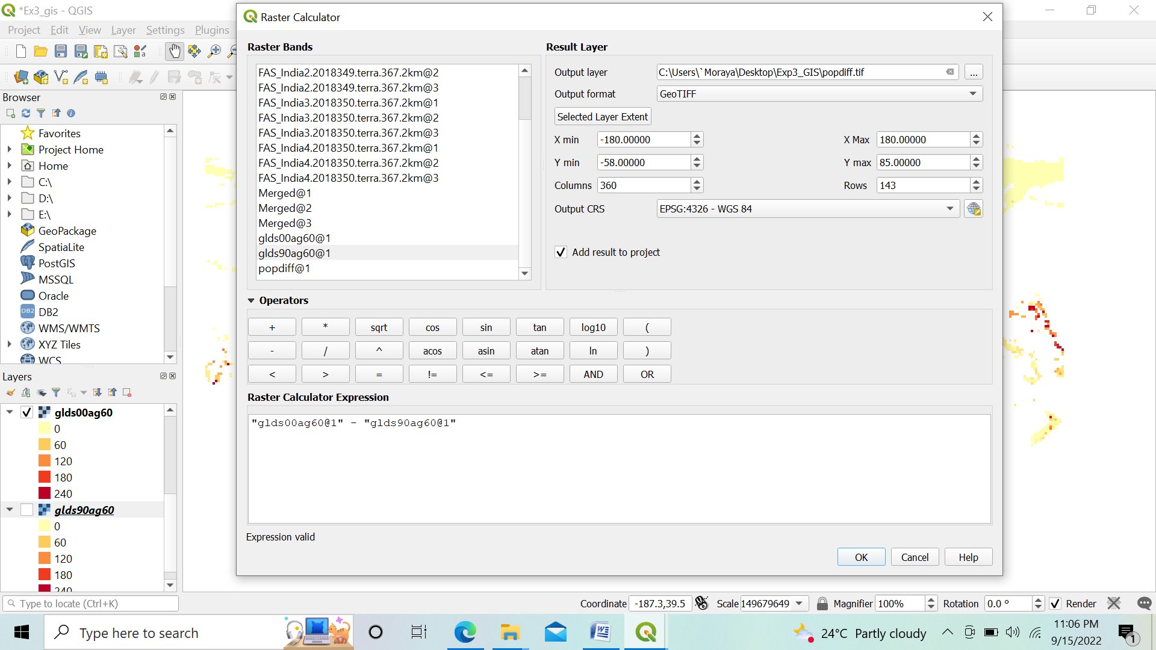

➢ Remove the other two layers i.e. glds00ag60.asc and glds90ag60.asc

➢ Double click on pop_diff layer.

➢ Select symbology

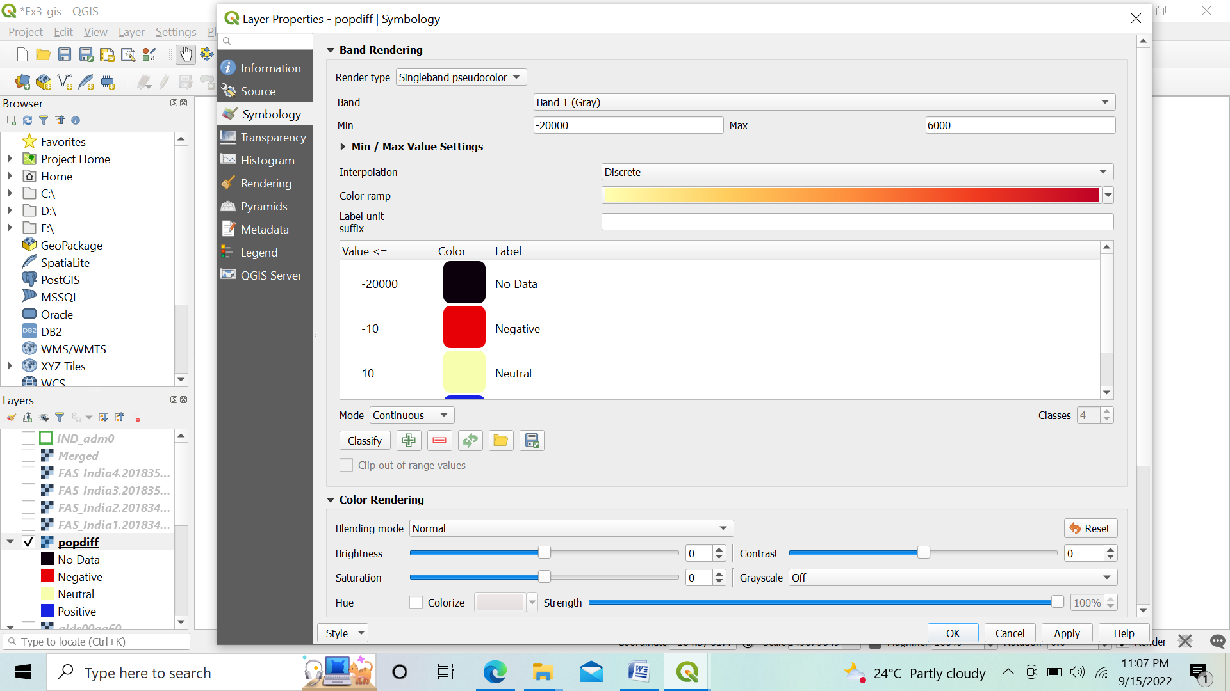

Set Render Type to “Single band Pseudo color”, Interpolation as Discrete, and remove all classification and add as shown in figure above using button. After all settings press “OK”.

➢ Layer will appear like given below.

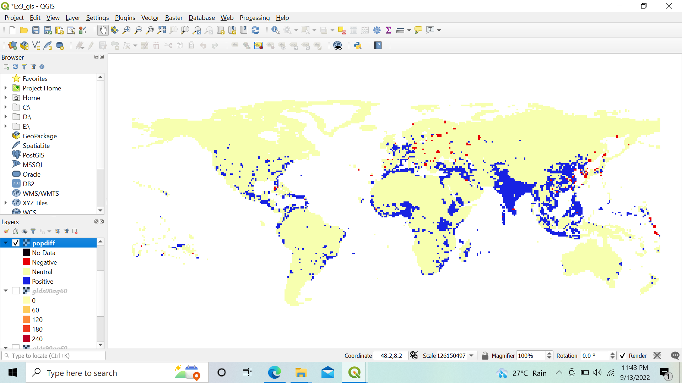

Explore an area of your choice and check the raster band value to verify the classification rule.

➢ The red pixel shows negative changes and blue shows positive changes.

**c) Raster Mosaicking and Clipping**

➢ Go to Layer → Add Layer → Add Raster Layer

➢ Select the following “.tif” raster images for India from data folder. FAS_India1.2018349.terra.367.2km.tif

FAS_India2.2018349.terra.367.2km.tif

FAS_India3.2018349.terra.367.2km.tif

FAS_India4.2018349.terra.367.2km.tif

➢ Press open

➢ In data source manager | Raster window click Add.

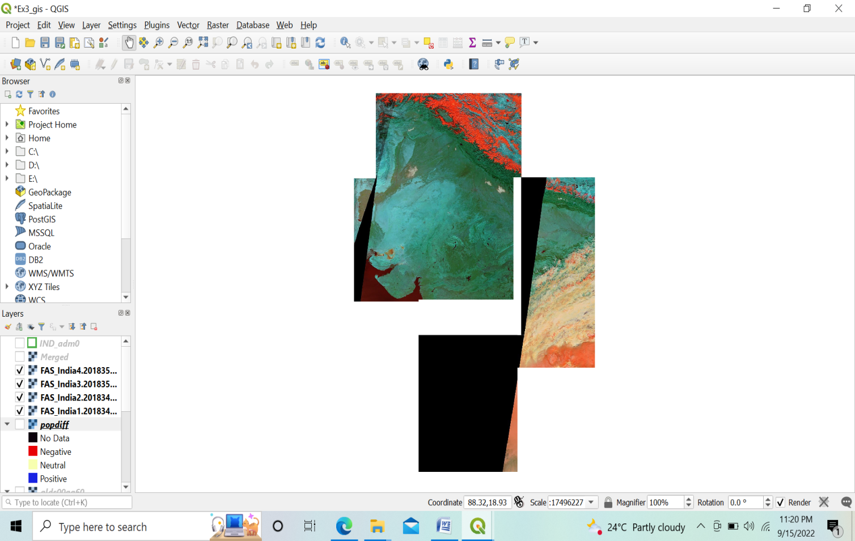

➢ Go to Raster → Miscellaneous → Merge. In merge dialog window select above 4 layers & press ok.Save the file with name Merge_file.tif

Press run close the Merge window dialog box.

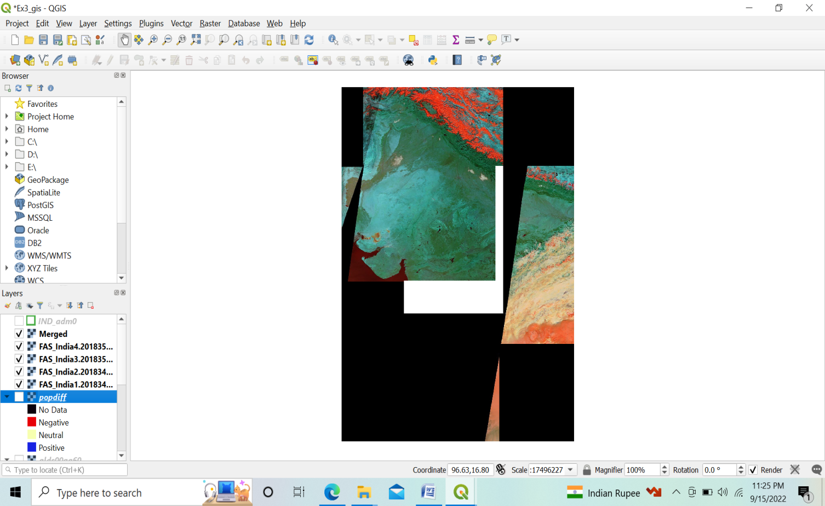

You can now deselect other layers and only keep the merged raster file.

Go to Layer→ Add Vector Layer → Select

Add IND_adm0.shp file.

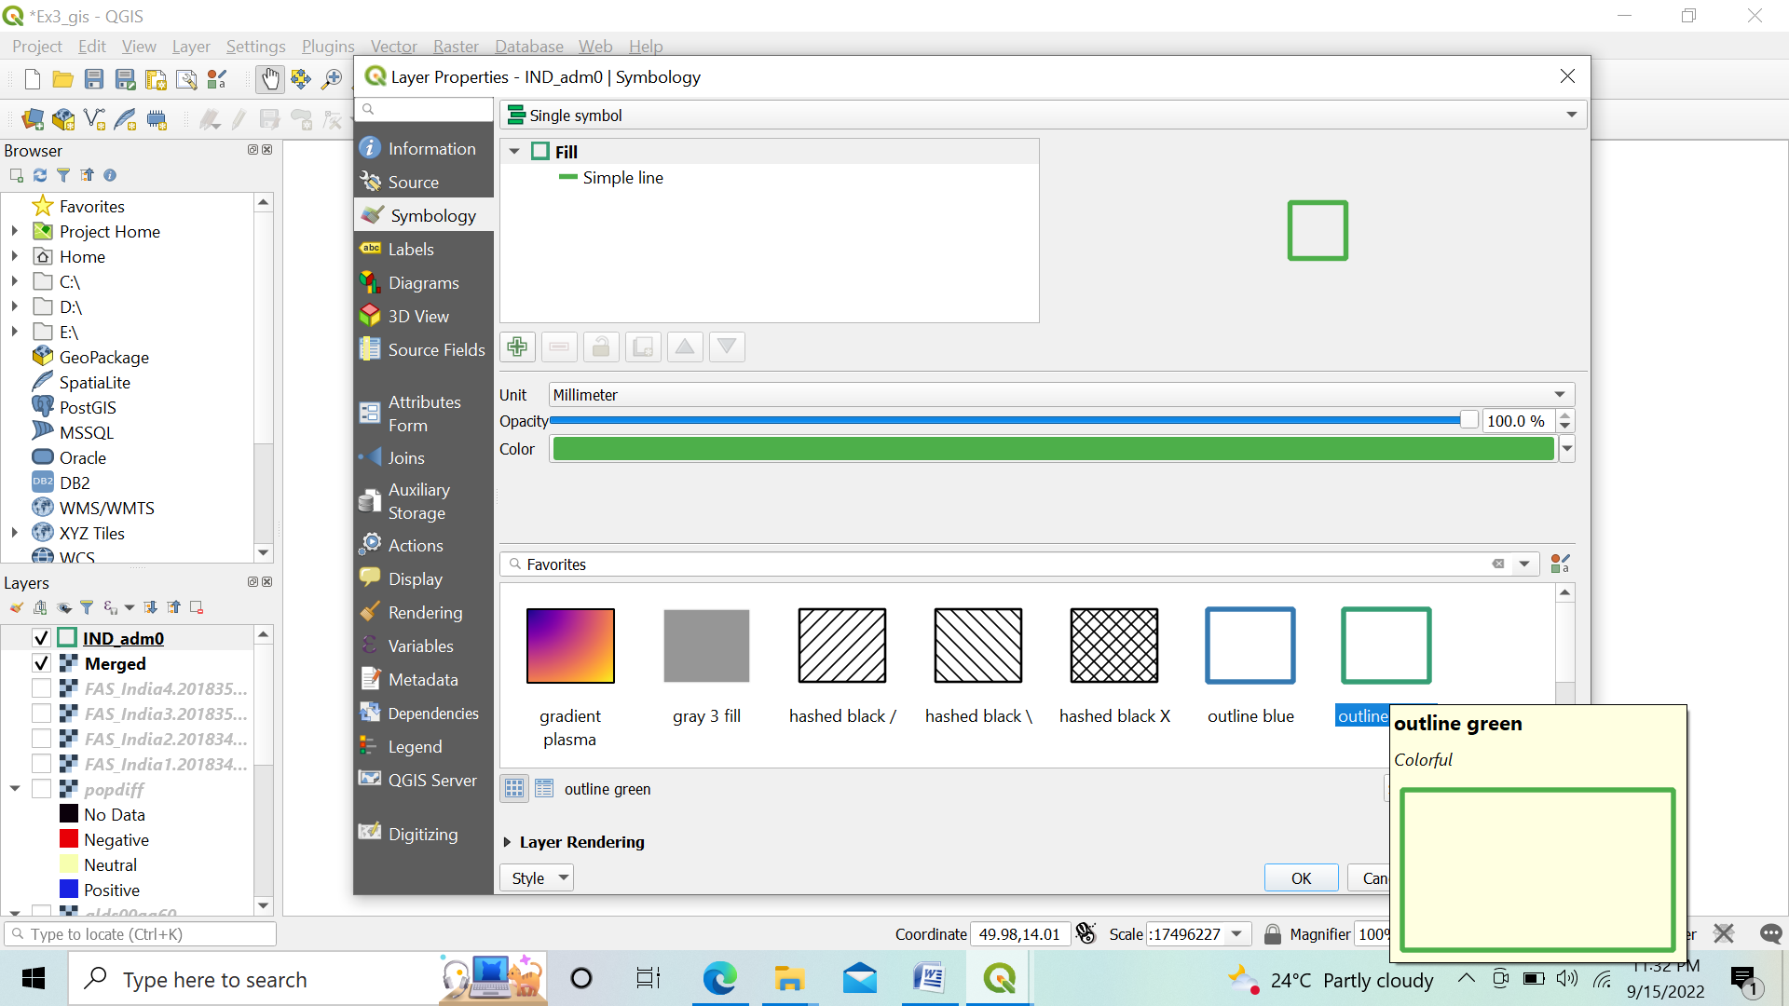

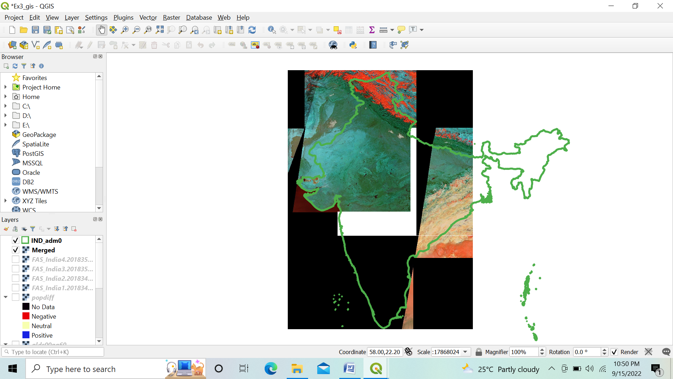

Go to Raster → Extraction → Clip Raster by Mask Layer

Select the merge raster image as input and Ind_adm0 as mask layer.

Select a file name and location for clipped raster as Clipped_File.tif

Press RUN

After Clipping :

